HOW TO SETUP XTREME SERVER SETUP

Items required:-
Hardware:
- Server System: -
  - 2 network card,
  - 4 core processor,
  - 8Gb RAM,
  - minimum 10Gb hard drive.
- USB flash drive (2gig minimum) or
- Ubuntu 18.04.5 CD
- Desktop/Laptop with Windows OS
- Internet connectivity
Software:
- ubuntu 18.04.5 ISO (Server version) / ubuntu 18.04.5 bootable cd (Server version)
- ISO to USB Creator (RUFUS)
- Xtreme Server packages from this link https://bitbucket.org/emre1393/xtreamui_mirror/src/master/)
Processes involve: -
- If Ubuntu 18.04.5 CD is available proceed to server installation step, but if you are using USB flash drive (2gig minimum) continue with how to write ubuntu 18.04.5 ISO to USB flash drive.
- Login to Desktop/Laptop with Windows OS,
- download ISO to USB Creator (RUFUS) from this link (https://rufus.ie)
- Download ubuntu 18.04.5 ISO if you don’t have the ISO from this link (https://releases.ubuntu.com/18.04.5/ubuntu-18.04.5-live-server-amd64.iso)
- Plugin or insert USB flash drive to a usb port on Desktop/Laptop with Windows OS
- Launch RUFUS application on Desktop/Laptop with Windows OS

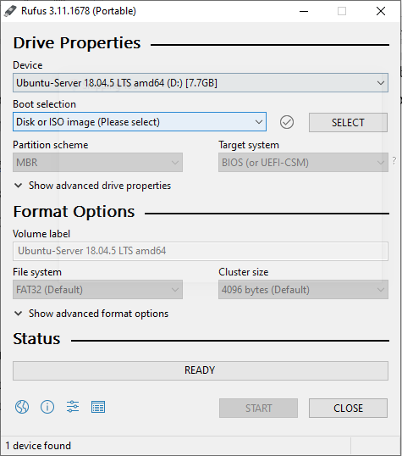
- Click on select and navigate to where ubuntu 18.04.5 ISO is located
- Click start (ensure that your flash drive is empty because the drive will be formatted by RUFUS)
- After the process is completed click Close and safely unplug the USB flash drive from the Desktop/Laptop with Windows OS
Server installation step
- Connect server to internet via one of (2 network card)
- Power on the server and enter Bios setup
- Insert the bootable USB flash drive (Ubuntu 18.04.5) or Ubuntu 18.04.5 CD
- Make (bootable USB flash drive (Ubuntu 18.04.5) or Ubuntu 18.04.5 CD as first boot, restart the server.
- Select your language
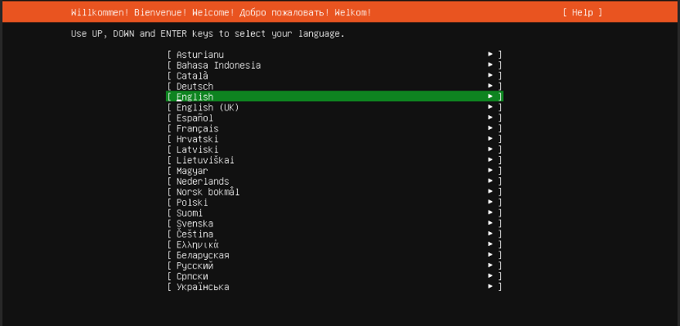

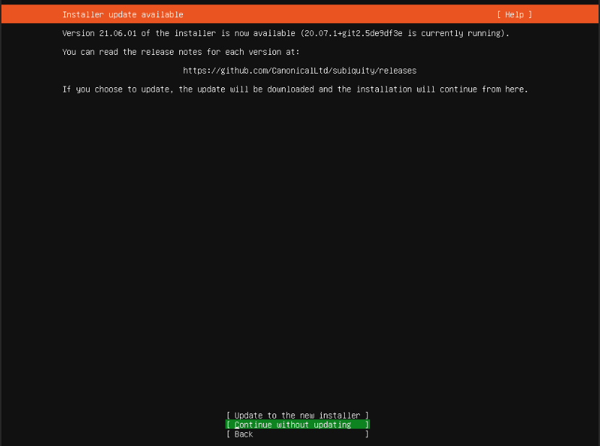
- continue without update

- select keyboard layout
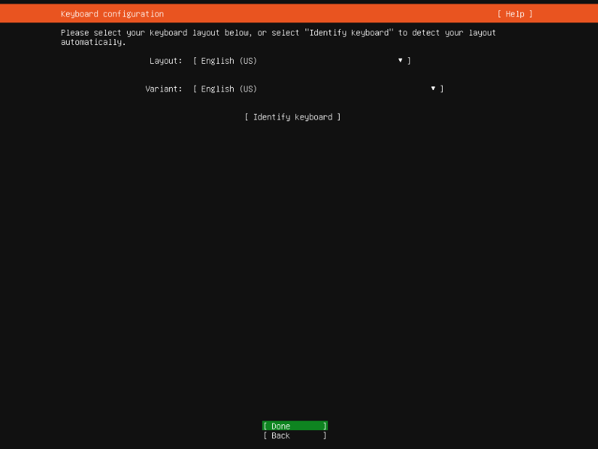

- select done (your system will acquire DHCP IP or set static IP )
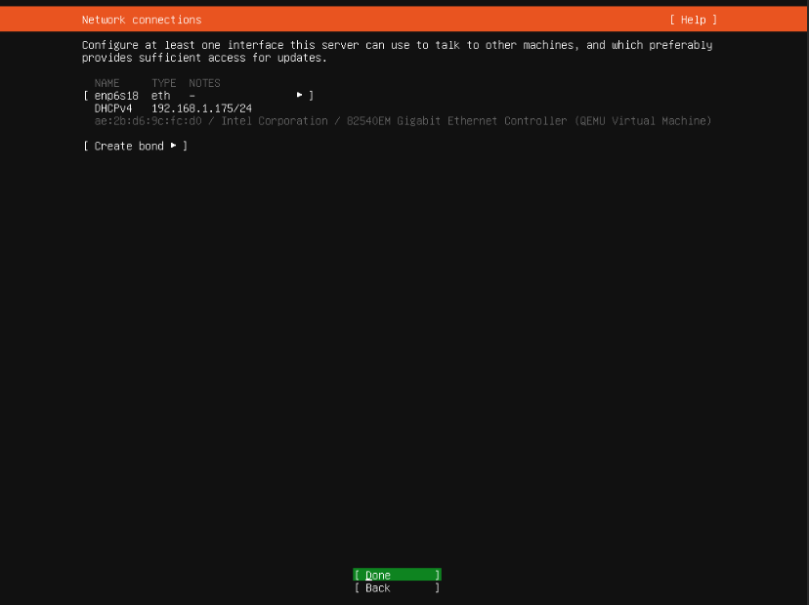

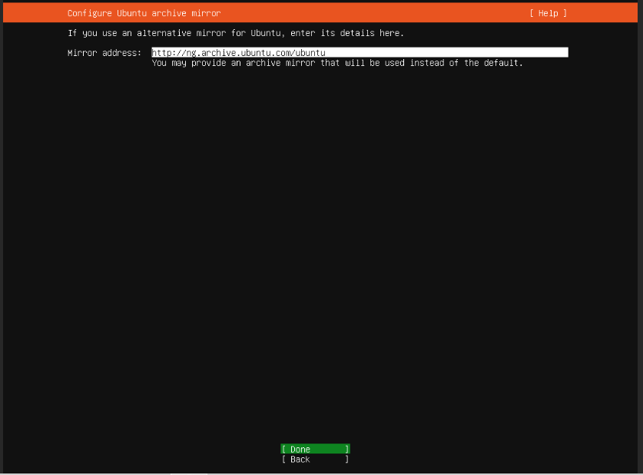
- Select Done

- Select the HDD to install on
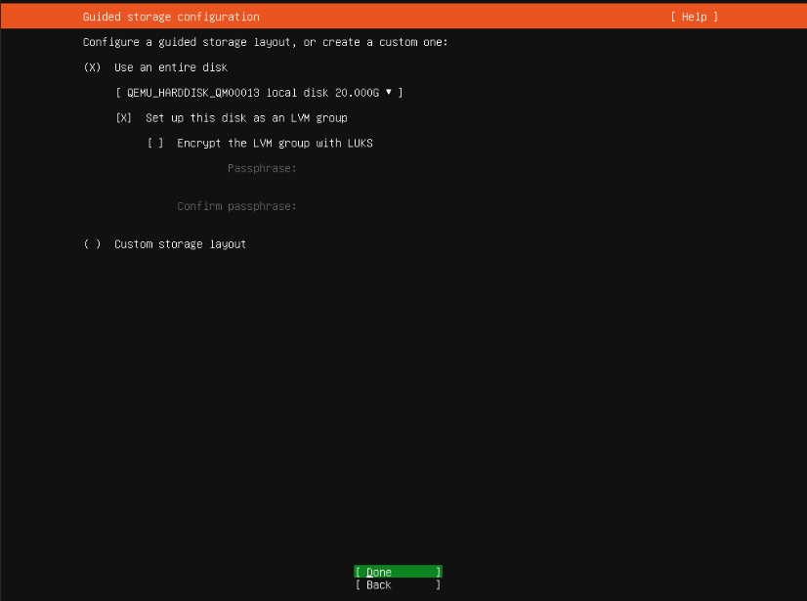

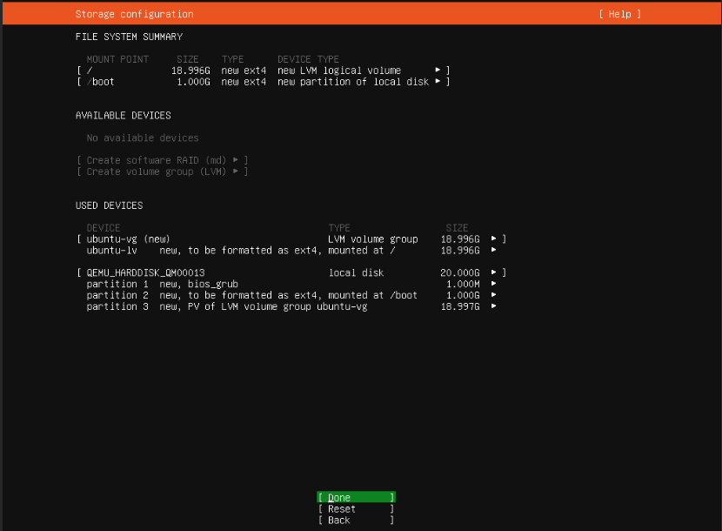
- Select Done

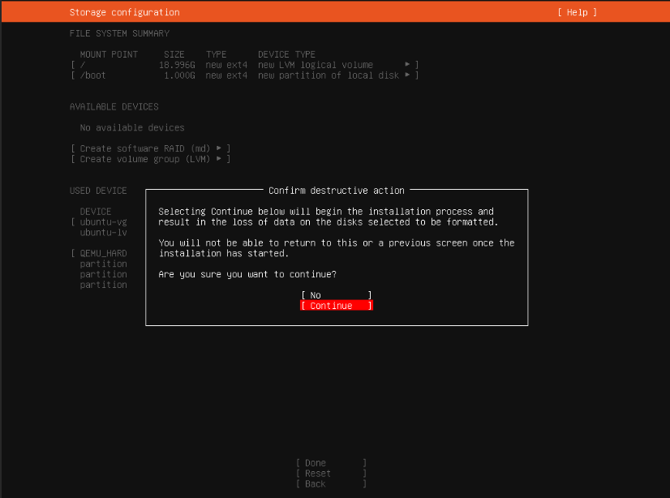
- select continue

- create user name and password
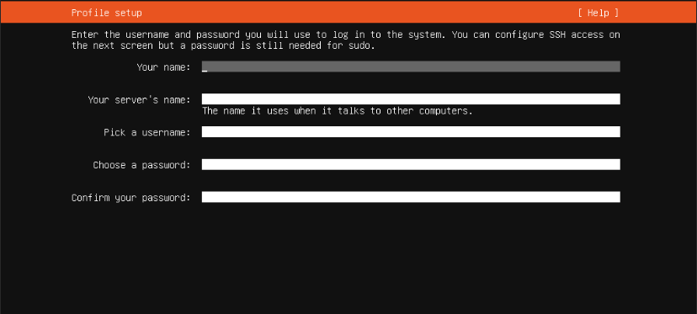

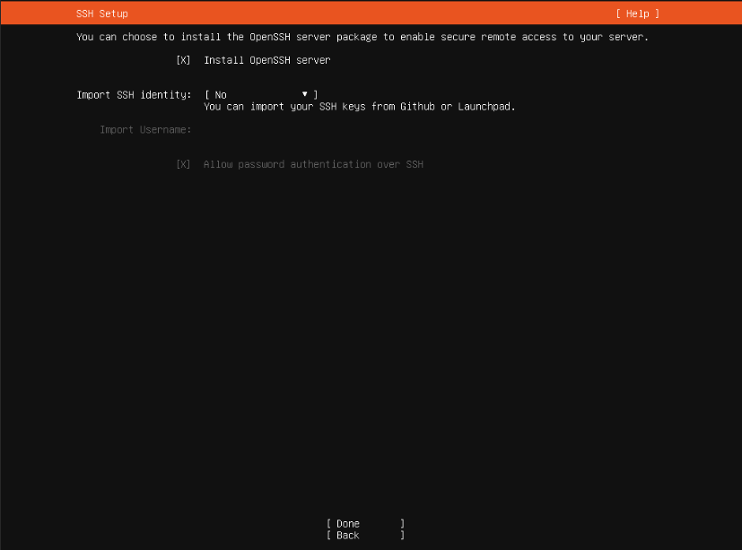
- Select install ssh (this will help to manage the server remotely)

- Select Done

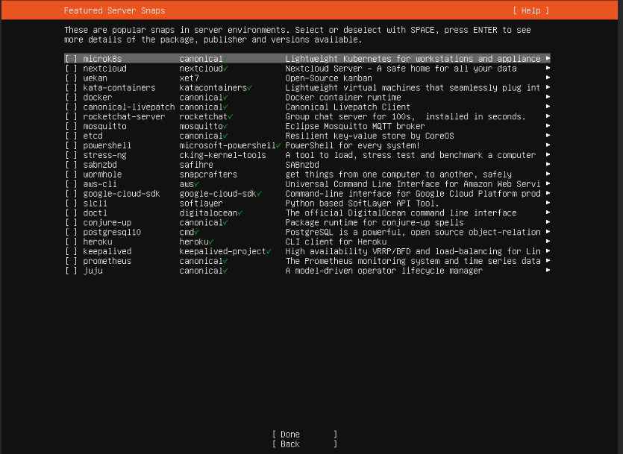
- Allow installation of security update to complete
- Reboot once the installation is done
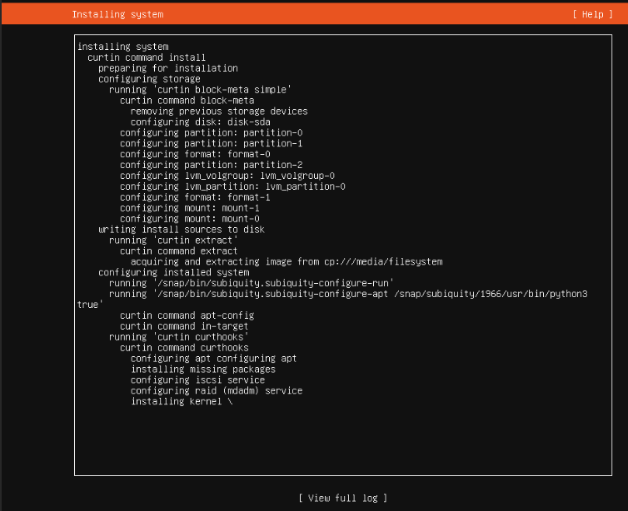

Xtreme Server installation step
update your ubuntu first, then install panel as described bellow:
- sudo apt-get update && sudo apt-get upgrade -y;
- sudo apt-get install libxslt1-dev libcurl3 libgeoip-dev python -y ;
- rm install.py; wget https://bitbucket.org/emre1393/xtreamui_mirror/downloads/install.py;
- sudo python install.py
- If you want a whole NEW installation, choose MAIN.
- Follow the installation process (click yes where require)
- Enter MySQL password when prompt to do so (this can be any password of your choice)
- After a successful installation, (Please store your MySQL password!)

Xtreme Server Management
- logon to Xtreme management page (http://your server ip address: 25500)
- The default user name and password is (admin/admin) which you are advised to change
- If you want a whole NEW installation, choose MAIN.

